Pasos a seguir
SuiteCommerce InStore Installation: empezar de aqui
https://8025197.app.netsuite.com/app/help/helpcenter.nl?fid=chapter_4111569414.html

Beginning the installation: https://8025197.app.netsuite.com/app/help/helpcenter.nl?fid=section_1525913096.html

Requisitos mínimos

Required Features and Settings for SCIS
The following NetSuite features are required to use SuiteCommerce InStore (SCIS). To enable features in NetSuite:
- Go to Setup > Company > Setup Tasks > Enable Features.
- Check the boxes next to all the features listed in the following table.
- Click Save.

Company | Locations  Multi-Language
Accounting | Accounting Periods
Tax | Advanced Taxes
Transactions | Multiple Shipping Routes  Promotion Codes
Items & Inventory | Gift Certificates  Bar Coding and Item Labels  Inventory  Multi-Location Inventory
CRM | Upsell Manager
Web Presence | Web Site  Advanced Site Customization  Descriptive URLs  SuiteCommerce InStore  Host HTML Files  Online Ordering
SuiteCloud | Custom Records  Advanced PDF/HTML Templates  Client SuiteScript  Server SuiteScript  SuiteScript Server Pages  SuiteScript 2 Server Pages (SCIS 2020.1 or later)  Custom Transactions

SuiteCommerce InStore (SCIS) requires specific accounting preferences and tax settings in your NetSuite account.

To set accounting preferences for SCIS:
- Go to Setup > Accounting > Accounting Preferences.
- Set the following accounting preferences:
  - On the General subtab, clear the box next to Void Transaction Using Reversing Journals.
  - On the Items/Transactions subtab, select a Default Income Account from the list.
- Click Save.

To automatically charge for shipping:
- Go to Setup > Accounting > Setup Tasks > Shipping.
- Check the Charge for Shipping box.
- Click Save.

To configure SCIS tax settings:
- Go to Setup > Accounting > Nexuses. You must have at least one tax nexus set up.
- Go to Setup > Accounting > Set Up Taxes.
- Check the box next to Enable Tax Lookup on Sales Transactions.
- Check the box next to Customers Default to Taxable.
- Check the box next to Charge Out of District Sales Taxes.
- Check the box next to Per-Line Taxes on Transactions.

Note: In some cases, the Per-Line Taxes on Transactions preference conflicts with the feature, Multiple Shipping Routes. If you find that the preference is not available, go to Setup > Company > Enable Features. On the Transactions subtab, clear the box next to Multiple Shipping Routes. Click Save. Then, you can check the Per-Line Taxes on Transacations box, and enable the Multiple Shipping Routes feature again.

- Under Charge Sales Tax on Store Orders, select Always.
- Select a Default Tax Code.
Note: If there is no tax code or tax item on the customer record, then the tax is calculated based on the SCIS location address.

- Under Tax Code Lists Include, select Tax Groups and Tax Codes.
- Set up a tax code for each location where you will be using SCIS.
- Click Save.

- Go to Setup > Accounting > Tax Schedule. Verify that the nexus corresponding to each location is taxable.
After you have configured accounting preferences and tax settings, you can install the SuiteCommerce InStore SuiteApp.

Permit Refunds or Exchanges for Transactions in Closed Accounting Periods
By default, after an accounting period has been closed, sales associates cannot process a refund or exchange for transactions that occurred during that period. To disable the restriction for a period, you can use the Allow Non-G/L Changes option. The option allows adding non-posting transactions to a closed period.

Perform the following steps in NetSuite. The first two can be one-time tasks:

Note
Sales associates and other users who do not have the Allow Non-G/L Changes enabled in their role cannot enter non-posting transactions to a closed period, even if the Allow Non-G/L Changes option for a period is checked.

1. To ensure you have Allow Quick Close enabled:
- Go to Setup > Accounting > Preferences > Accounting Preferences.
- On the General tab, scroll to the end of the General Ledger section.
- Ensure Allow Quick Close of Accounting Periods is checked. If not, check the option.
- If you checked the option, click Save.

2. To adjust the SCIS Clerk role to Allow Non-G/L Changes:
- Go to Setup > Users/Roles > User Management > Manage Roles.
- Click Edit for the SCIS Clerk role.
- On the Permissions tab, click Setup.
- In the Add field, select Allow Non-G/L Changes.
- Click Add.
- Click Save.

3. To enable Allow Non-G/L Changes for a Closed Accounting Period:
- Go to Setup > Accounting > Manage G/L > Manage Accounting Periods.
- Expand the desired Period Name to display the period to enable.
- Verify that the Period Close column is checked for the period.
Open periods do not require the option to allow non G/L changes.
- Click the Period Name to display the details.
- Check the Allow Non-G/L Changes box.
- Click Save.

Siguientes pasos
Agregar bundles de ultima versión:
- Reference Product Review Records
- Reference Product Lists Records
- SuiteCommerce InStore

Setear el employee record
Lists -> Employees -> Employees
Entramos al employee record, y seteamos una location en Classification.
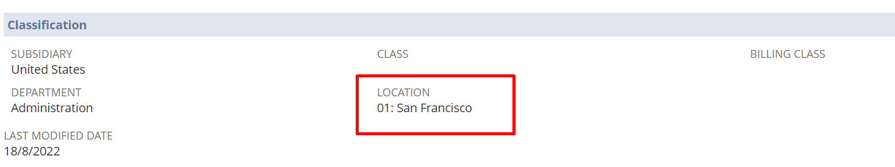
Agregar SCIS Locations en la pestaña Custom en el employee record.
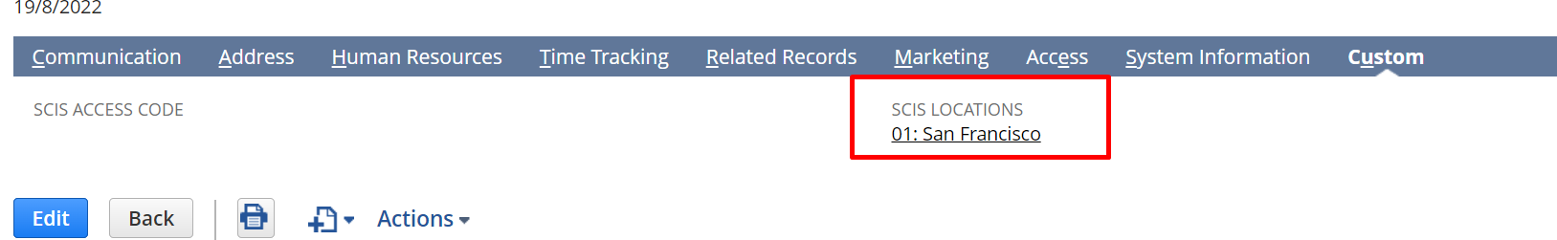
Y dar accesos de Administrator y SCDeployer.

Setear el dominio del sitio SCIS
https://nlcorp.app.netsuite.com/app/help/helpcenter.nl?fid=section_4425996079.html
Tengo que seguir las guias de system management para crear un dominio
Asumimos que:
Tener un dominio del cliente, y pedirle que nos cree un subdominio:
Feng es dueño del dominio suitewebstore.com, entonces me creo el subdominio ilan-scis.suitewebstore.com para usar.
Busco la lista de mis sitios web:
Commerce -> Websites -> Website List -> seleccionar el de InStore.
El ID del sitio, es el que está en el link de este:
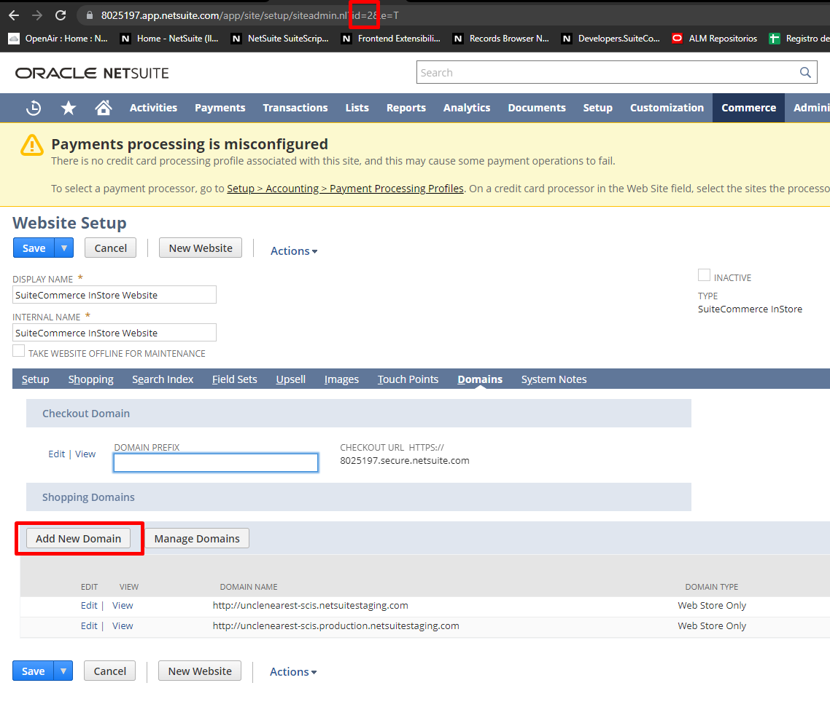
Selecciono en add new domain para asociar un nuevo dominio.
Este subdominio yo lo inserto en NetSuite, en la cuenta del cliente, cuando hago el add del subdominio:
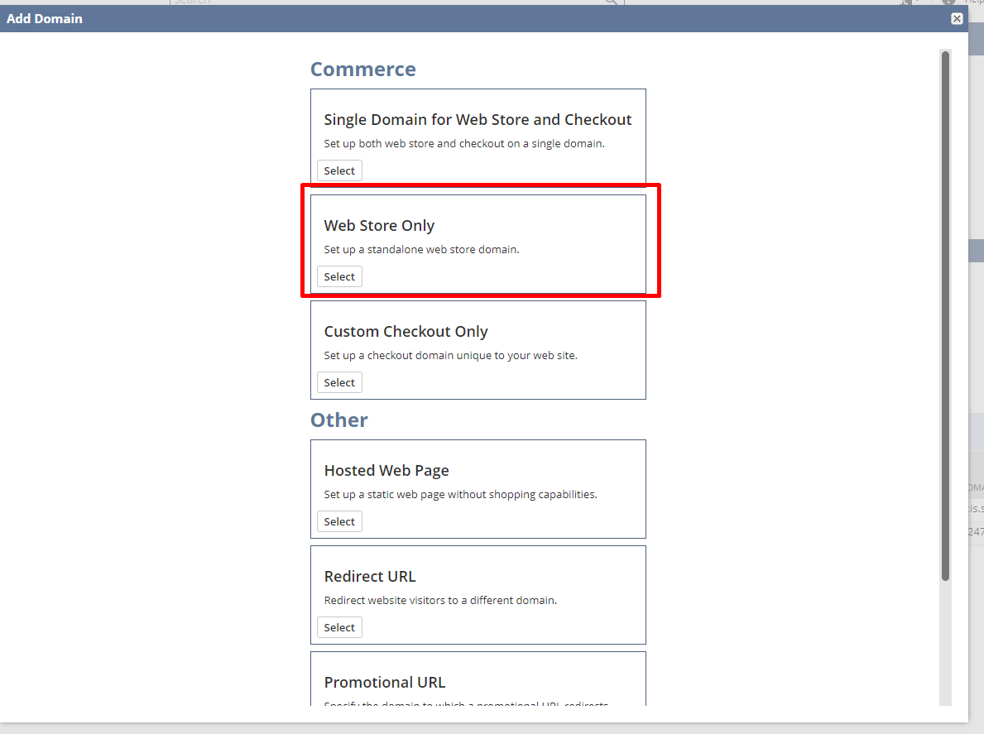
Selecciono web store only.
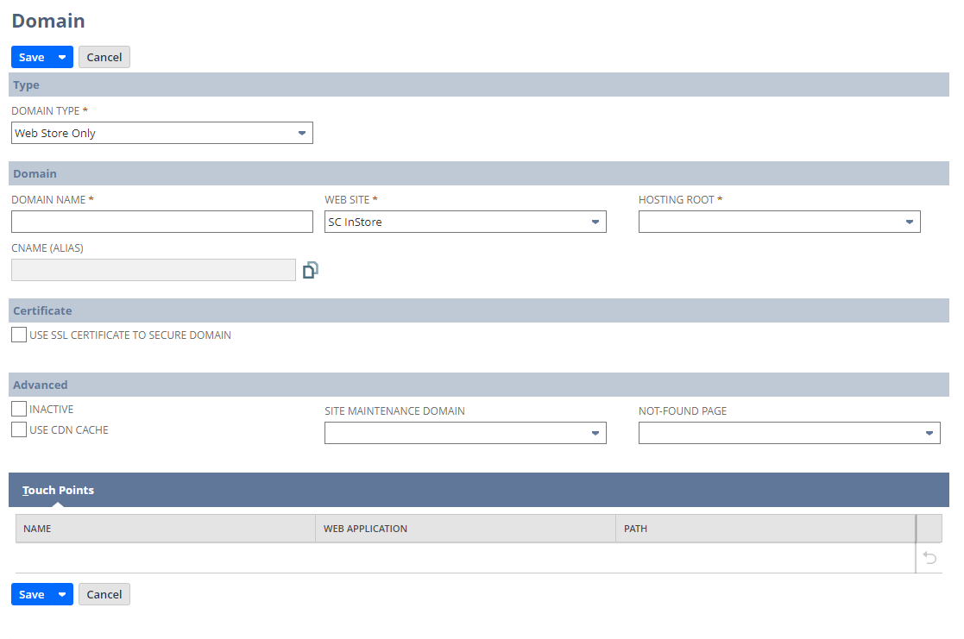
Aquí relleno con:
- Subdomain name que me da el cliente
- Web Site: SC InStore
- Hosting root: Live Hosting Files
- Touchpoins: View HomePage
- Use ssl certificate to secure domain
- Use CDN Cache
Entonces queda así:
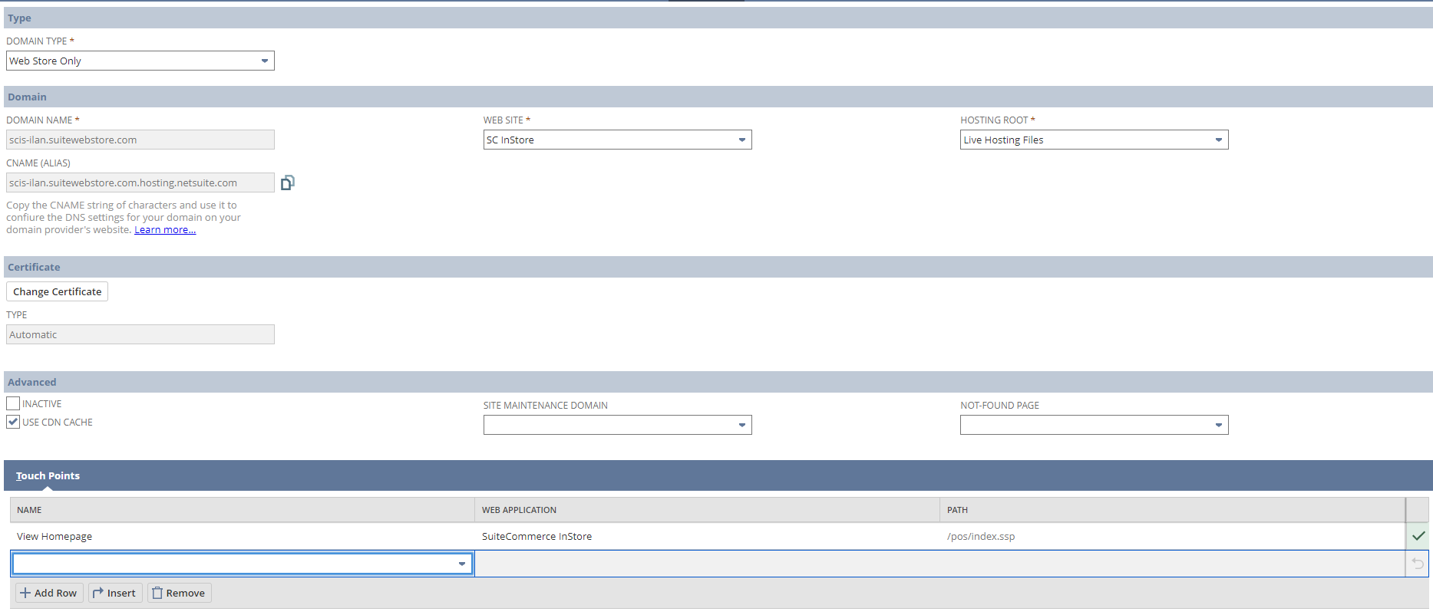
Guardo.
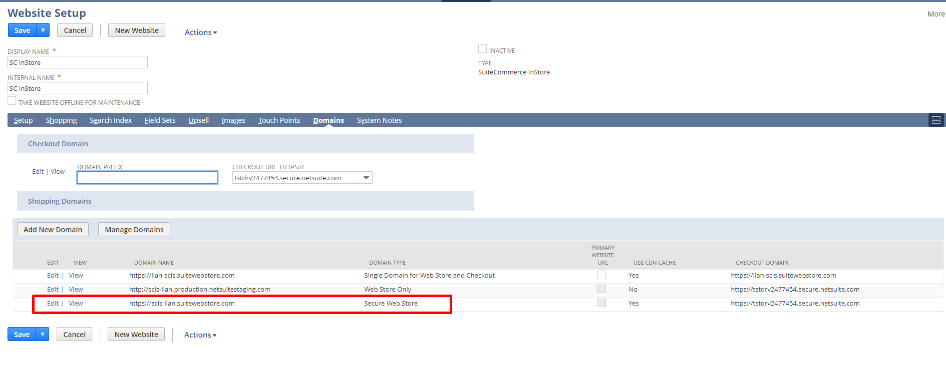
Una vez que fue seteado el dominio, NS te crea un CNAME.
Hay que esperar una hora que se setee, esto lo seteo feng, así que el equipo de customer IT debería setear este CNAME que te da NS en la configuración DNS del cliente.
Documentación:
https://tstdrv2477454.app.netsuite.com/app/help/helpcenter.nl?topic=DOC_section_N2479403
https://tstdrv2477454.app.netsuite.com/app/help/helpcenter.nl?fid=section_1526632554.html
https://nlcorp.app.netsuite.com/app/help/helpcenter.nl?fid=section_4425996079.html

Repository set up
Una vez que tenemos seteado el dominio en el que va a correr nuestra app correctamente (pasos anteriores), pasamos a desarrollar nuestra extension.
Siguiendo la guía de acá:
https://tstdrv2477454.app.netsuite.com/app/help/helpcenter.nl?fid=section_1541202297.html&whence=
Sigo los mismos pasos que mi guía de creación de repositorios. (Guias -> General Proyectos -> Repositorios + extensiones). O también mirando la guía:
https://confluence.corp.netsuite.com/pages/viewpage.action?spaceKey=SOI&title=SCIS+Extension+Creation+and+Deployment+Guide

Mismos pasos que la guía:
Customization -> SuiteBundler -> Search & Install Bundles y busco SuiteCommerce Extension Management -> install, tiene el ID 426586.
Luego, voy a Documents -> Files -> File Cabinet, y descargo el bundle de ExtensionsDevelopmentTools más reciente, con este id 426586.
Entro en la carpeta del proyecto, creo la carpeta extensions, y descomprimo en la carpeta extensions las dev tools descargadas, luego entro a una consola, y en la carpeta del proyecto raíz y corro:
npm i --save-dev eslint@3.9.1 eslint-config-airbnb@13.0.0 eslint-plugin-requirejs@3.0.0

Luego, dentro de la carpeta extensions:
npm install
Creo las ramas necesarias

Extension management
Creo la extension:
Gulp extension:create
Me va a pedir:
- Set Your Extension Fantasy Name – Provide a name for your extension as you want it to appear in the NetSuite user interface. This can contain special characters and spaces. For example: My Cool Extension!
- Set Your Extension Name – Provide a name for your extension’s files and folders within your development environment.
- Set the Vendor Name – Enter your business, vendor, or partner name.
- Assign a Version Number– Add a version number for your extension.
- Set a Description for Your Extension – Provide some text to describe your extension. This string can contain spaces and special characters.
- This Extension Supports – Select one of the following options:
  - SuiteCommerce Online – To create an extension for SuiteCommerce or SuiteCommerce Advanced.
  - SuiteCommerce InStore – To create an extension for SuiteCommerce InStore.
Selecciono aquí InStore y deselecciono el otro.

Fetch step: cuando hago gulp extension:fetch, me va a pedir que indique que es, ahí elijo SCIS.
El sitio no tiene una activación de extensiones para el sitio de SCIS, por lo tanto, hay que crear una activación por primera vez, para esto vamos a tener que modificar uno de los archivos de gulp para que cuando hagamos “fetch” se cree esa primera activación.
Este es el error:
“Error in task gulp extension:fetch
Error Message
Could not download all the extension files{}
Error Details”
Vamos a gulp\extension-mechanism\configurations.js, modificamos la línea y dentro del if en línea 11 agregamos: && source != null && target != null
Luego ya estamos listos para hacer un deploy de la extensión.
Hacemos gulp extension:fetch –to –account (y numero de cuenta)
Luego, hacemos gulp extension:create, en un momento me pide SuiteCommerce Online o SuiteCommerce InStore, de ahí elegimos, InStore.
Cuando hacemos el gulp extension:deploy –to da un error:
There is no theme_path configured. You need to run gulp extension:fetch before to get the initial setup files. Aborting.
Hacer “gulp extension:deploy” sin –to.
Luego, tenemos que entrar a Commerce -> Extensions -> Extension Manager y hacer una nueva activación con la extension subida nueva.

Cuando actualizamos una extension:
Customization -> List, Record & fields -> Record Types -> Select SC ExtMech Extension and press on “List”
Buscamos nuestra extension:
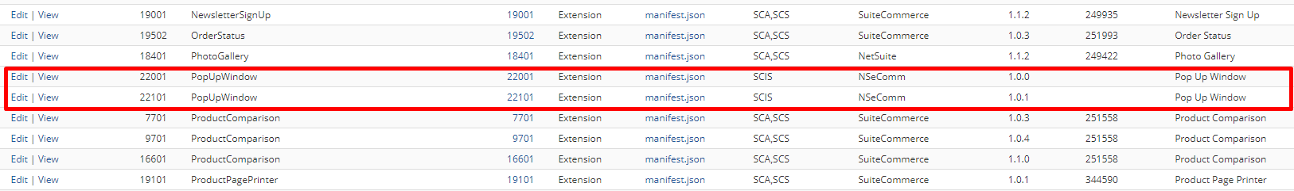
Ingresamos en uno de estos dos, y miramos si el target está seteado igual:
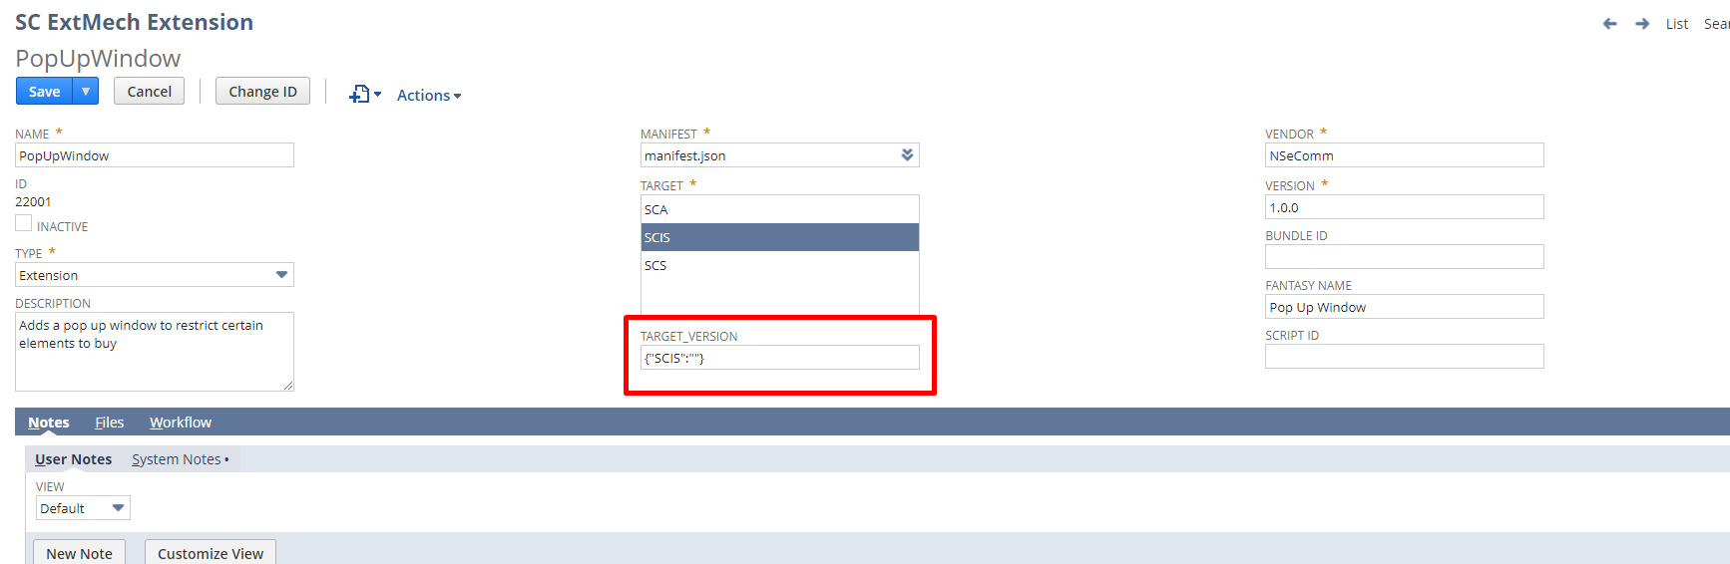
Por lo que vemos aquí, el target no está seteado.
Podemos borrar esto, y luego, lo que hacemos es repetir el proceso y hacer, gulp extension:fetch, luego un créate y luego un deploy, una vez hecho esto, vamos a crear una nueva activación con el dominio YA creado y funcionando que esté asociado a nuestra APP (mismo dominio para acceder a la app de SCIS que lo tiene que proveer el cliente). De ahí, hacemos la activación y ponemos la extensión activa.

Pasos que pueden fallar
Token based authentication: Setup -> Company -> Enable Features, tab de SuiteCloud, enable token based authentication.
Location error: Lists -> Employees -> Employees and edit my employee record and add something on location field.
Errores con el dominio
Commerce -> Website -> Website List: elijo el sitio de InStore, edito y accedo. Click derecho y pongo ver código fuente.
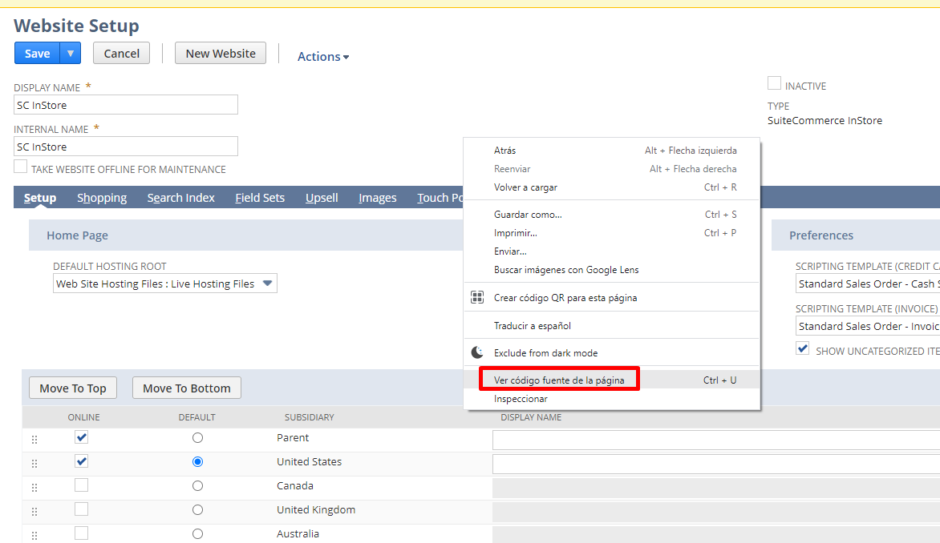
Vemos el Código Fuente del sitio, vamos hacia debajo de todo y vemos el servidor:
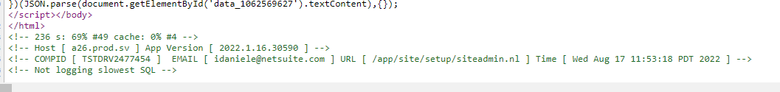
El servidor aquí es “sv”. Hay un mapeo para esto que dice si podemos crear subdominios en ellos:
AMS eu2
BOS na1
CHI na3
DUB eu1
SEA na2
SV -
Verifico si es alguno de na0 a na4 o SV, el resto no podemos crear un subdominio y tenemos que pedirle al cliente que cree el subdominio.
Crear un nuevo dominio con el nombre quequiera.production.netsuitestaging.com, eligiendo live hosting files, y como touchpoint home page view.

Solución:

Debugging
Tenemos una cuenta de testing asociada:
https://tstdrv2477454.app.netsuite.com/app/center/card.nl?sc=-29&whence=
El sitio de prueba de mi cuenta lo puedo usar: https://tstdrv2477454.app.netsuite.com/c.tstdrv2477454/pos/main.ssp?whence=&n=6
Archivo para modificar inStore, que es un file que podemos modificar on the fly para testear:
https://tstdrv2477454.app.netsuite.com/app/common/media/mediaitem.nl?id=337595&e=T

Debugger para cosas que faltan de SCIS

Identifying Required Features and Settings for SCIS
You can run a script that identifies features and settings that may have caused installation failure. Use the NetSuite debugger to run the script.

To generate a list of required features and settings:
- Copy the script displayed in the SCIS_CheckRequiredFeatures.js file in the NetSuite file cabinet at Web Site Hosting Files > Live Hosting Files > SSP Applications > NetSuite Inc. - POS > SuiteCommerce InStore > scripts. You can use the Search box in the File Cabinet to locate the file.
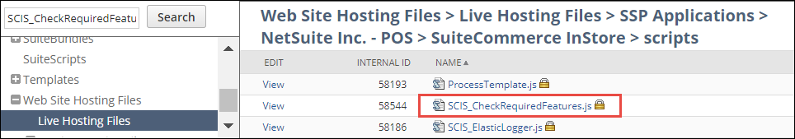
- Go to Customization > Scripting > Script Debugger.
- Enter the SuiteScript Debugger domain (by clicking the link as indicated) and then re-enter your login credentials if prompted.
- Set the API Version to 1.0.
- Paste the script code into the debugger.
- Click Debug Script and then click Continue.
If there are features required for SCIS that are not enabled in your account, they will be listed at the bottom of the page.
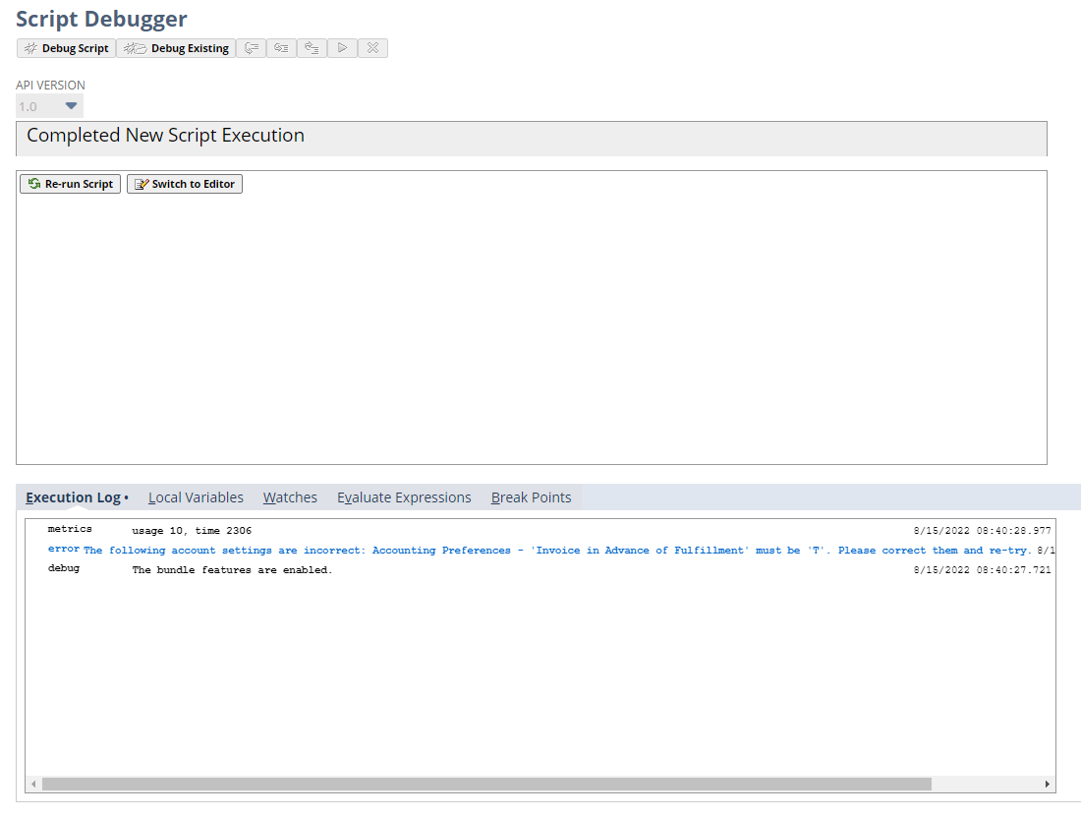

Instalo la version para windows de NetSuite InStore
https://nlcorp.app.netsuite.com/app/help/helpcenter.nl?fid=section_161842677458.html

Inicio la aplicación de NetSuite InStore, selecciono la cuenta de producción y el usuario:
idaniele@netsuite.com con la contraseña actual que uso ultima.
Elegir una cuenta en la que quiero correr.
https://nlcorp.app.netsuite.com/app/help/helpcenter.nl?fid=section_161350254557.html
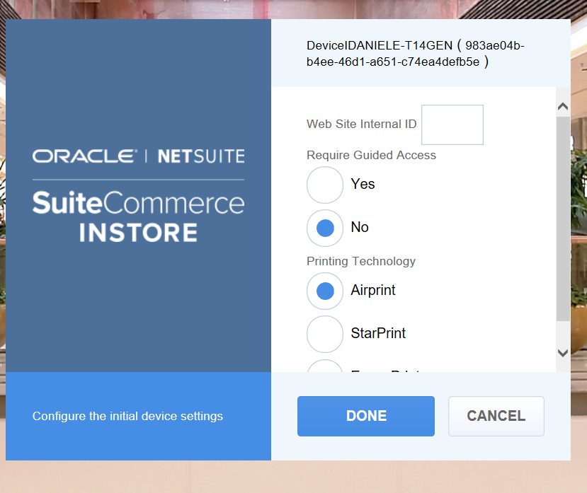
Llenar un website ID, entro en commerce -> websites -> website list, y elijo el sitio y lo edito.
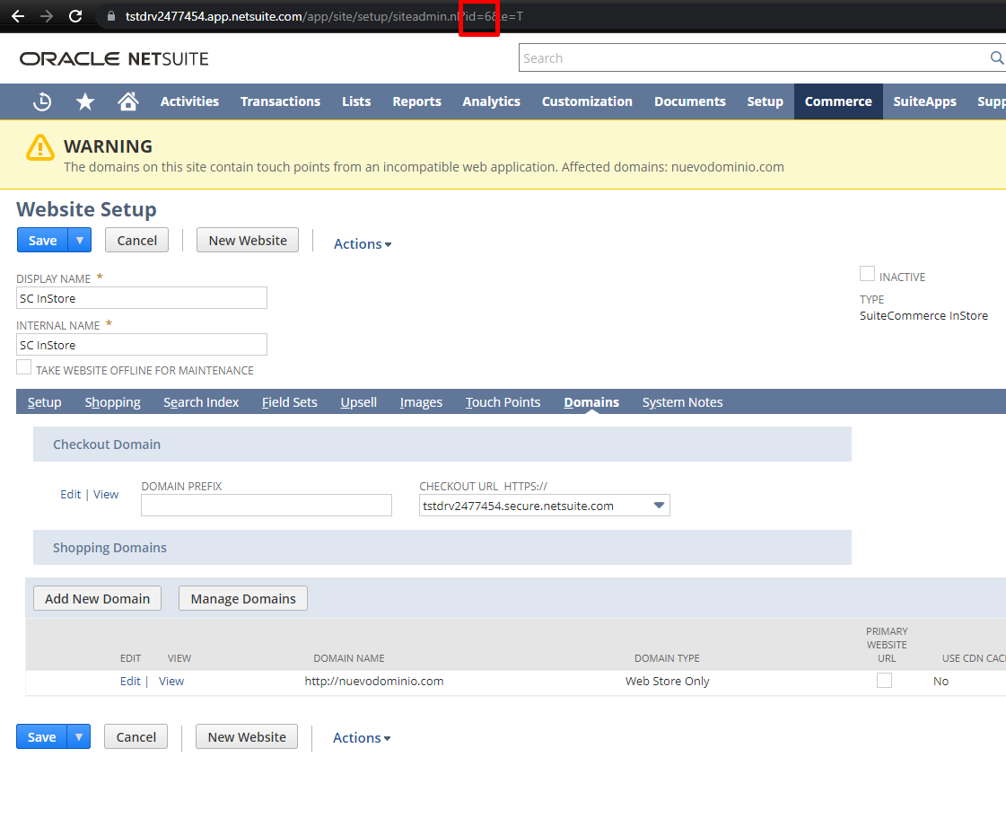

Usar SCIS Event Validators para pruebas:
Web developers can write custom logic into scripts that run before or after a specific event occurs in the shopping cart. For more information, read SCIS Event Validators.

SuiteCommerce InStore (SCIS) enables administrators to customize the application to meet specific business and design needs. The validator.js file contains code snippets that can run before or after a specific backend event occurs in the shopping cart. The pre-validation code defines what is returned. For example, either the event is not run (and an error message appears in the SCIS UI), or there is success ("1” is returned) and the event runs as expected.
This section includes reference information about how to modify the validator.js file and available methods, supported backend events, and a list of objects and their properties. Read the following topics for more information:
- How to Modify the validator.js File
- Methods
- Events
- Arguments

How to Modify the validator.js File
The validators.js file is installed by the SuiteApp. By default, the JavaScript is commented, but administrators or web developers can remove the comments in the code to use the default values or make changes to the file.

To modify the validator.js file:
- Go to Web Site Hosting Files > Live Hosting Files > SSP Applications > NetSuite Inc. - POS > SuiteCommerce InStore.
- Click Edit next to validators.js.
- Remove the comment around the code snippet to use the default values included in the file. You can also edit the code to customize your implementation of SCIS.
- Click Save.

Methods
The following methods are available:
- addLine(data)
- updateLine(data)
- getLines()
- getSummary()

Seguir mirando en: https://nlcorp.app.netsuite.com/app/help/helpcenter.nl?fid=section_1498501603.html

Error invalid device:
https://nlcorp.app.netsuite.com/app/help/helpcenter.nl?fid=section_4773470562.html
Invalid role or account device restrictions.

Errores communes:
https://nlcorp.app.netsuite.com/app/help/helpcenter.nl?fid=section_1560206422.html

Algo que quizás sirve pero no tanto

Disable or Exclude unneeded User Event Scripts
NetSuite provides various methods for preventing execution of a user event script. For SCIS, you should use either of the following two:
- Disabling a Script Deployment via its Context (recommended)
- Disabling a Script by Clearing its Role Assignment

Disabling a Script Deployment via its Context
The type of processing that executes a script is referred to as the execution context. If a script is not required to complete a processing task within a certain context, then you can often improve performance by disabling that script from running in that context.
For SCIS, the contexts in which a script can be safely disabled are:
- Payment Postback — Used with SCIS-supported payment devices
- Web Application — Used for submitting SCIS records
Use the procedure in this task to view and disable scripts that are not required in the selected SCIS processing context.

To view and disable scripts by context:
- Log into NetSuite as an Administrator.
- Go to the desired script deployment context list to review:
  - Payment Postback Scripts — Go to Commerce > InStore > (Performance) Scripts on Webcontext
  - Web Application Scripts — Go to Commerce > InStore > (Performance) Scripts on Webapps
All scripts in the selected context that are included in your account display in a list. The list includes:
  - Record — The record or record-type that causes the script to execute. Execution occurs when an instance of that record is created or updated in a Payment Postback or Web Application context.
  - Number of Execution Context — The number of contexts under which the script is executed. For example, Script X might run under a Bank Connectivity context, Payment Postback context, and Promotions context, for a total of 4 contexts.
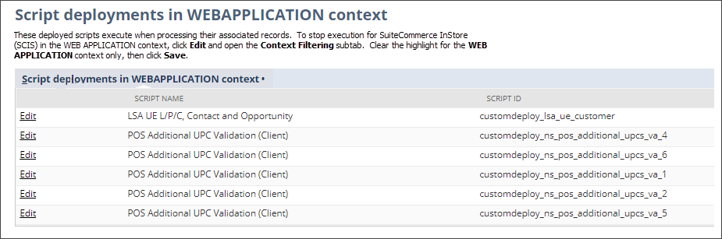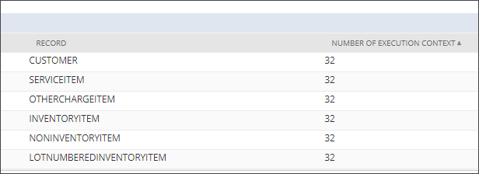
- Click Edit for the script to disable.
The Script Deployment page opens.
- Open the Context Filtering subtab.
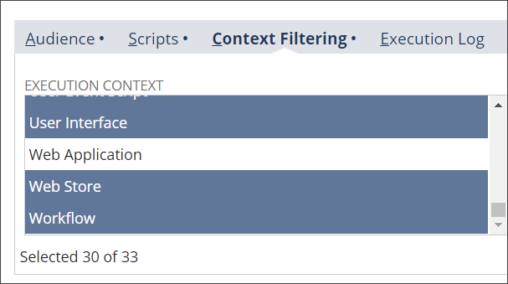
- In the Execution Context list, clear the highlighting on one or both of these contexts:
  - Payment Postback
  - Web Application

Important

Do not clear highlights for other contexts. Some contexts might already be cleared.

Tip

Hold the Ctrl key and click a highlight to clear it.

- Click Save.
- Repeat these steps as needed to disable other scripts in Payment Postback and Web Application contexts.

Disabling a Script by Clearing its Role Assignment
Disabling a script by clearing its role assignment applies to user event scripts only.

To clear a User Event Script’s Role assignment:
- Log into NetSuite as an administrator.
- Go to Customization > Scripting > Script Deployments.
- Use information from the task Find Scripts that affect records used by SCIS to locate the script Roles to adjust.
- Click Edit by the desired script.
- Go to the Audience section.
- If checked, clear the Roles >Select All box.
- To remove individual assignments, click those Roles to clear the highlights.
- Click Save.
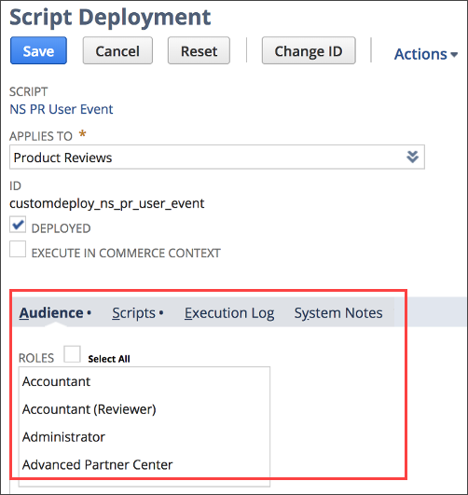

Puedo configurar el archivo de search fields o fieldsets acá, en NS_RP_ResetSearchFields.js:
https://nlcorp.app.netsuite.com/app/help/helpcenter.nl?fid=section_4180749958.html

Estos son los fields que vienen en el parámetro de beforeAddLine o afterAddLine:
https://nlcorp.app.netsuite.com/app/help/helpcenter.nl?fid=section_1498501603.html

Extensibility layer:
https://system.netsuite.com/help/helpcenter/en_US/APIs/SuiteCommerce/Extensibility/SCIS/Cart.html#voidLine

SCIS app:
https://tstdrv2477454.app.netsuite.com/c.tstdrv2477454/pos/main.ssp?whence=&n=6

